Spring Balance
# Source: AI Source: Provided by: [Data Path: Persons Table -> ID Column: 1, Name_En Column: Motasem Essam] -> From: [ChatGPT] on [7/17/2026]
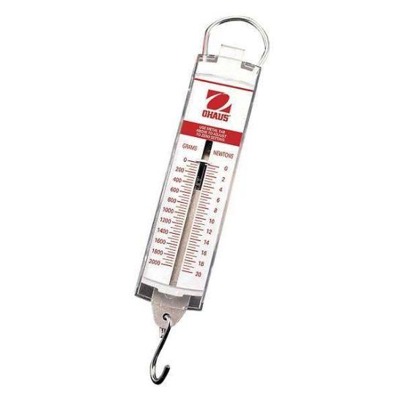
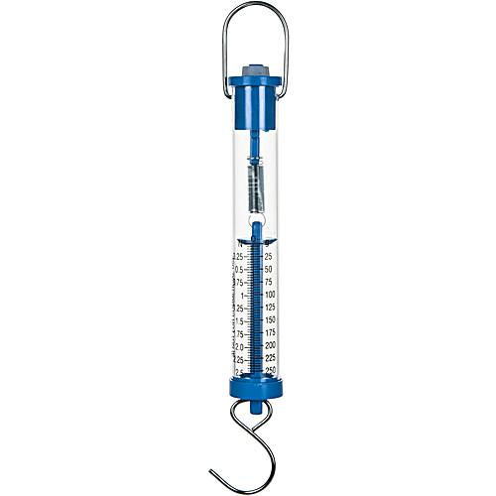
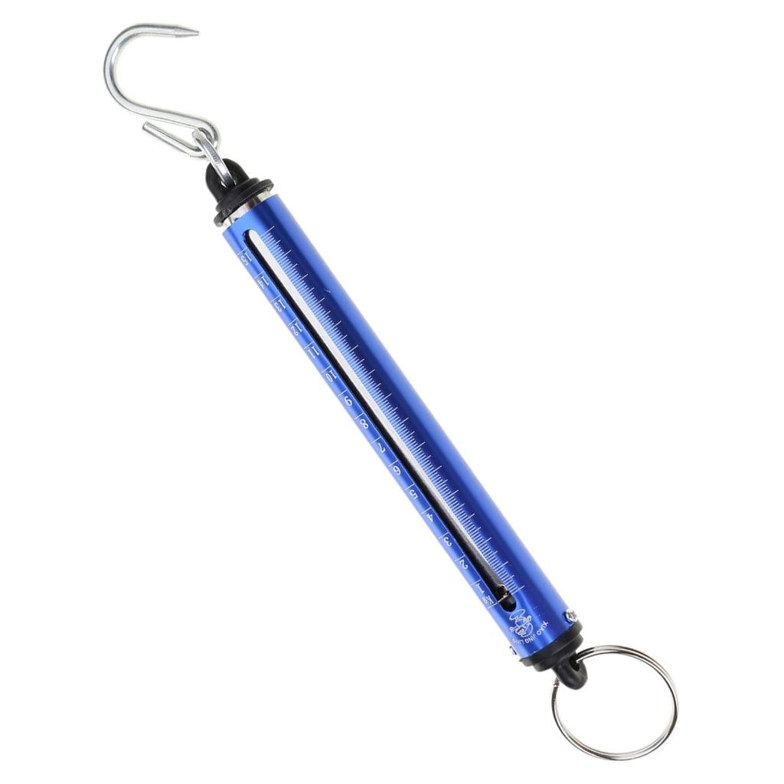
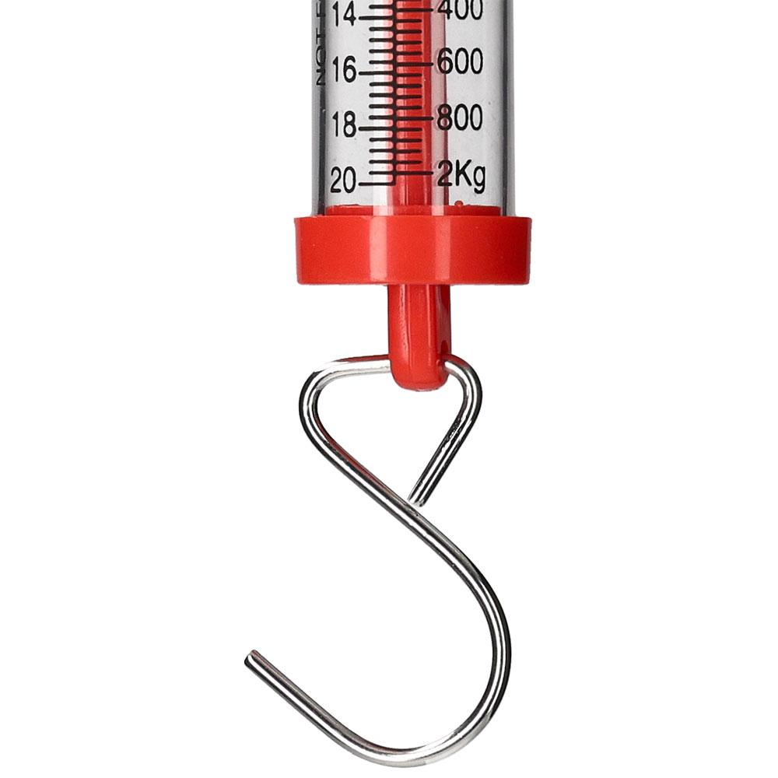
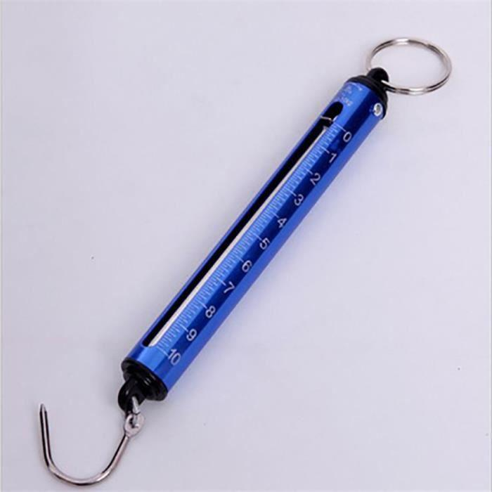
A Spring Balance is a force-measuring instrument used to measure the magnitude of a force, particularly the weight of an object, by measuring the extension or compression of a spring. It operates according to Hooke's Law, which states that the extension of a spring is directly proportional to the applied force within its elastic limit.
Spring balances are widely used in schools, laboratories, engineering, physics experiments, industry, and field measurements.

Definition
# Source: AI Source: Provided by: [Data Path: Persons Table -> ID Column: 1, Name_En Column: Motasem Essam] -> From: [ChatGPT] on [7/17/2026]
A Spring Balance is a mechanical instrument that measures force by observing the deformation (extension or compression) of a calibrated spring.

Purpose
# Source: AI Source: Provided by: [Data Path: Persons Table -> ID Column: 1, Name_En Column: Motasem Essam] -> From: [ChatGPT] on [7/17/2026]
A spring balance is used to:
- Measure force.
- Measure weight.
- Demonstrate Hooke's Law.
- Perform physics experiments.
- Compare forces.
- Measure tension in ropes and wires.
- Determine object weight in laboratories.

Principle of Operation
# Source: AI Source: Provided by: [Data Path: Persons Table -> ID Column: 1, Name_En Column: Motasem Essam] -> From: [ChatGPT] on [7/17/2026]
A spring balance works according to Hooke's Law.
Within the spring's elastic limit:
- Greater force → greater spring extension.
- The extension is proportional to the applied force.
- The extension is converted into a force reading using a calibrated scale.

Main Components
# Source: AI Source: Provided by: [Data Path: Persons Table -> ID Column: 1, Name_En Column: Motasem Essam] -> From: [ChatGPT] on [7/17/2026]
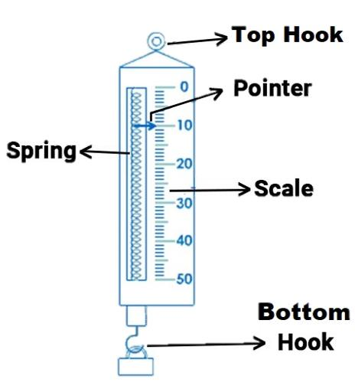
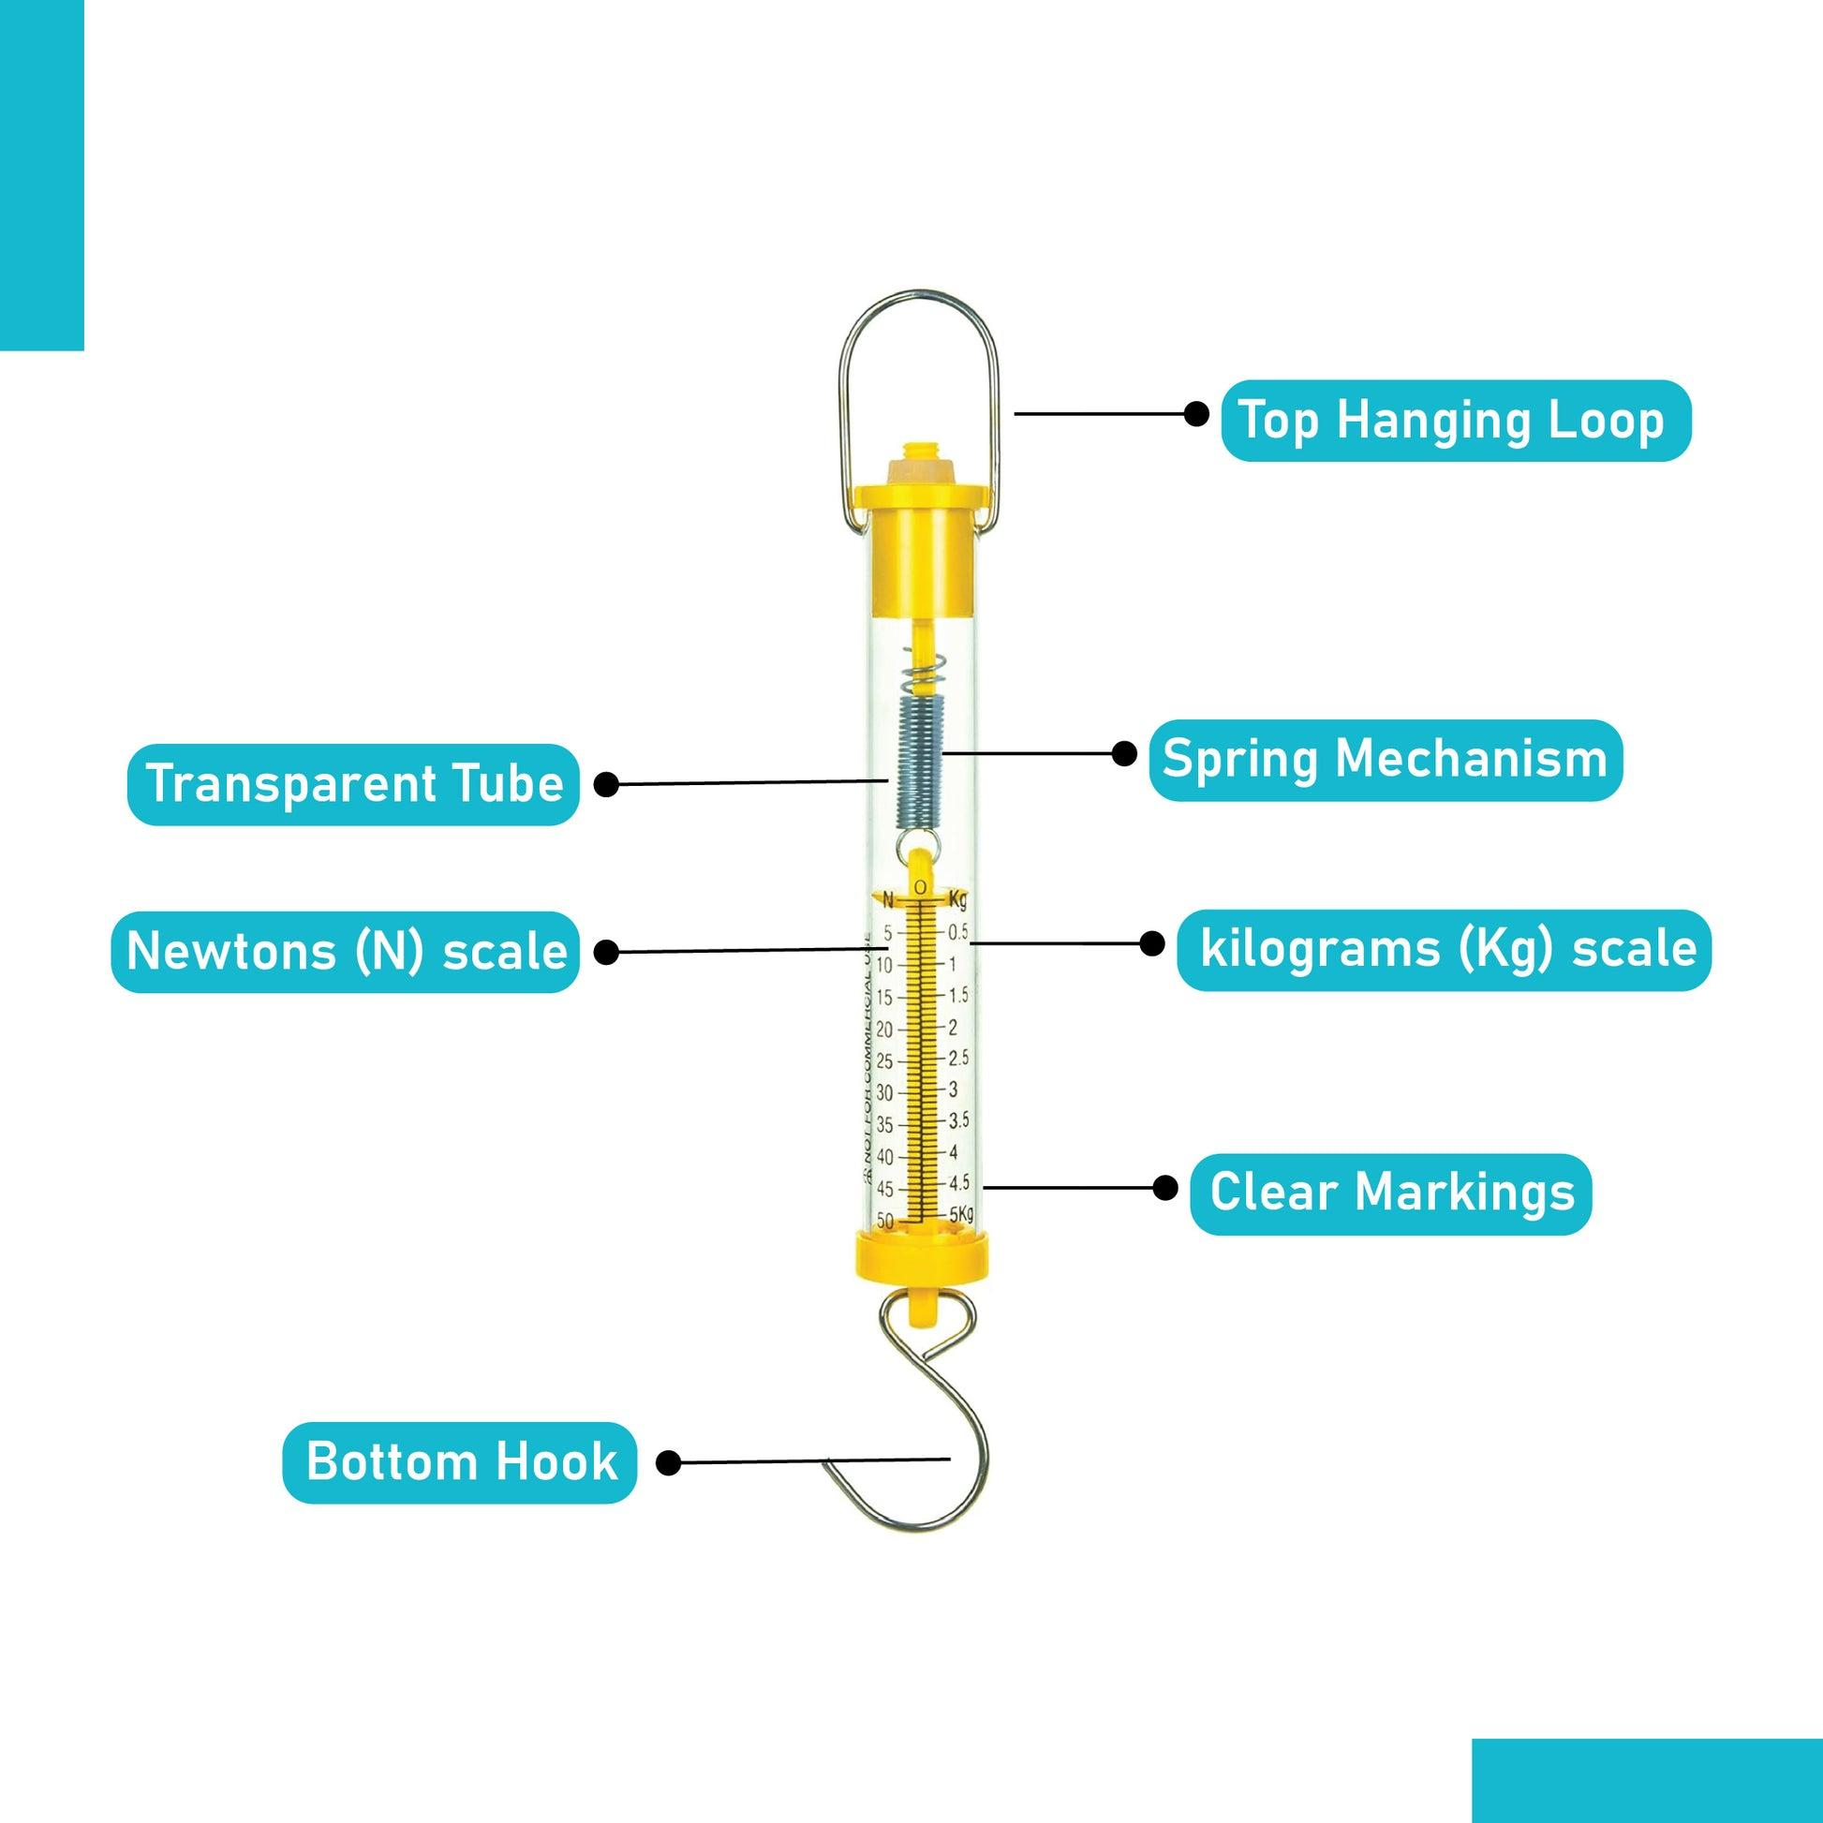
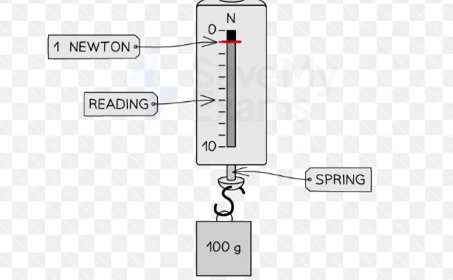
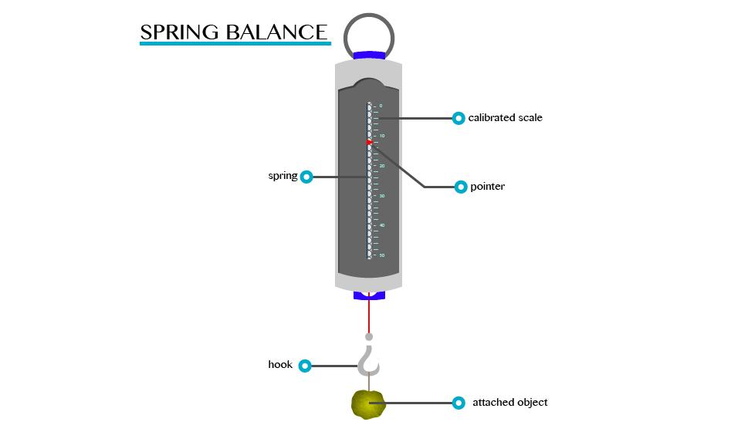
A typical spring balance consists of:
- Helical spring
- Hook
- Pointer
- Graduated scale
- Protective casing
- Suspension ring or handle

Types of Spring Balances

1. Hanging Spring Balance
# Source: AI Source: Provided by: [Data Path: Persons Table -> ID Column: 1, Name_En Column: Motasem Essam] -> From: [ChatGPT] on [7/17/2026]
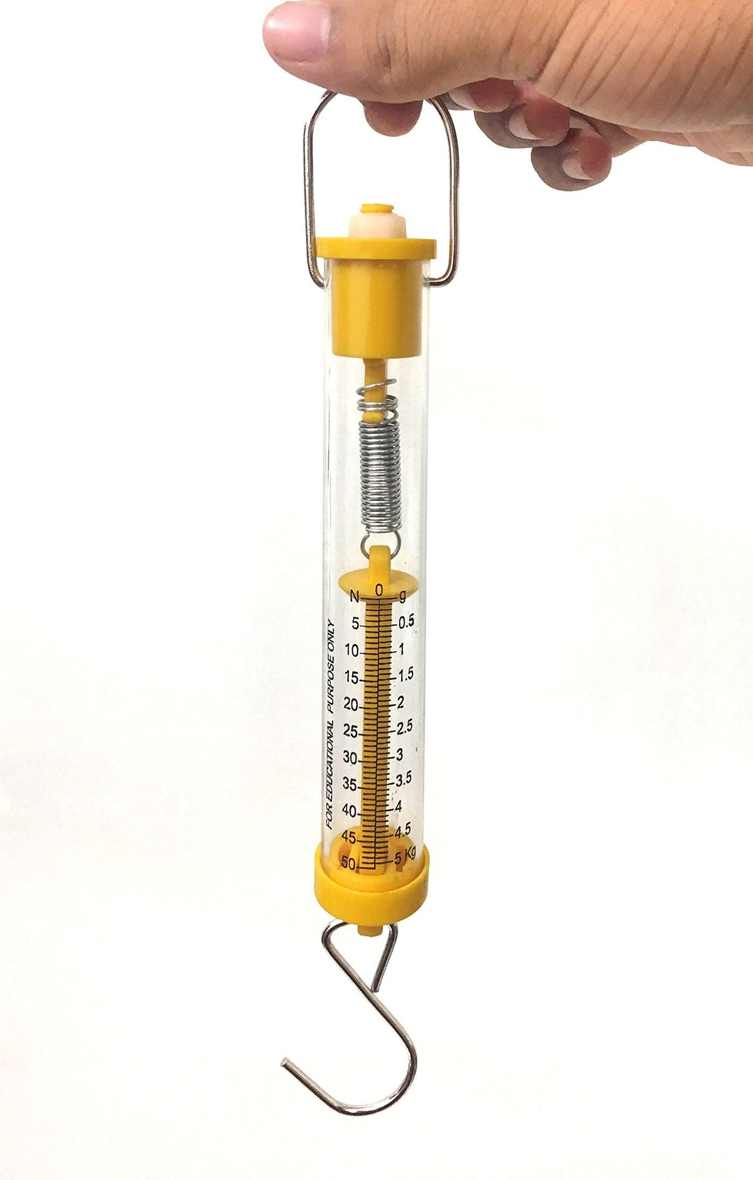
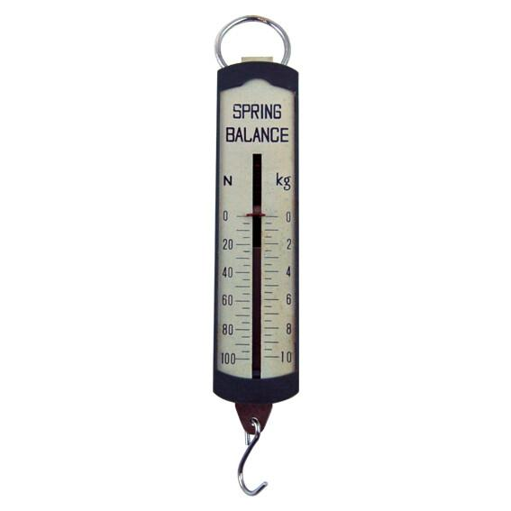
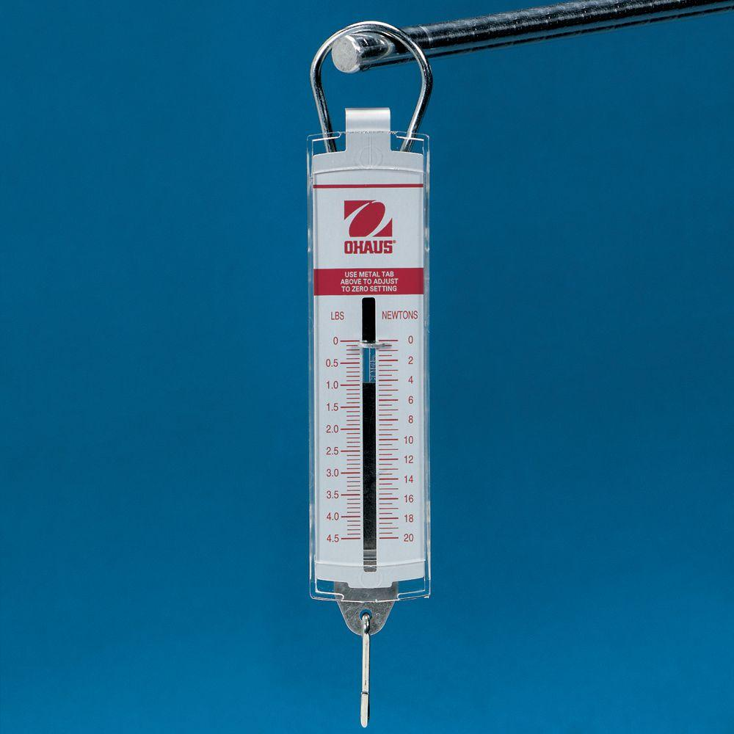
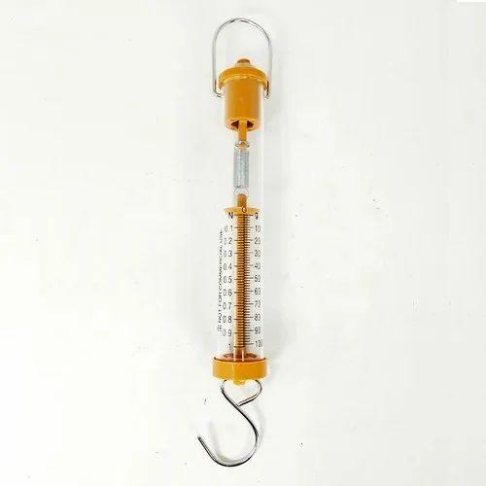
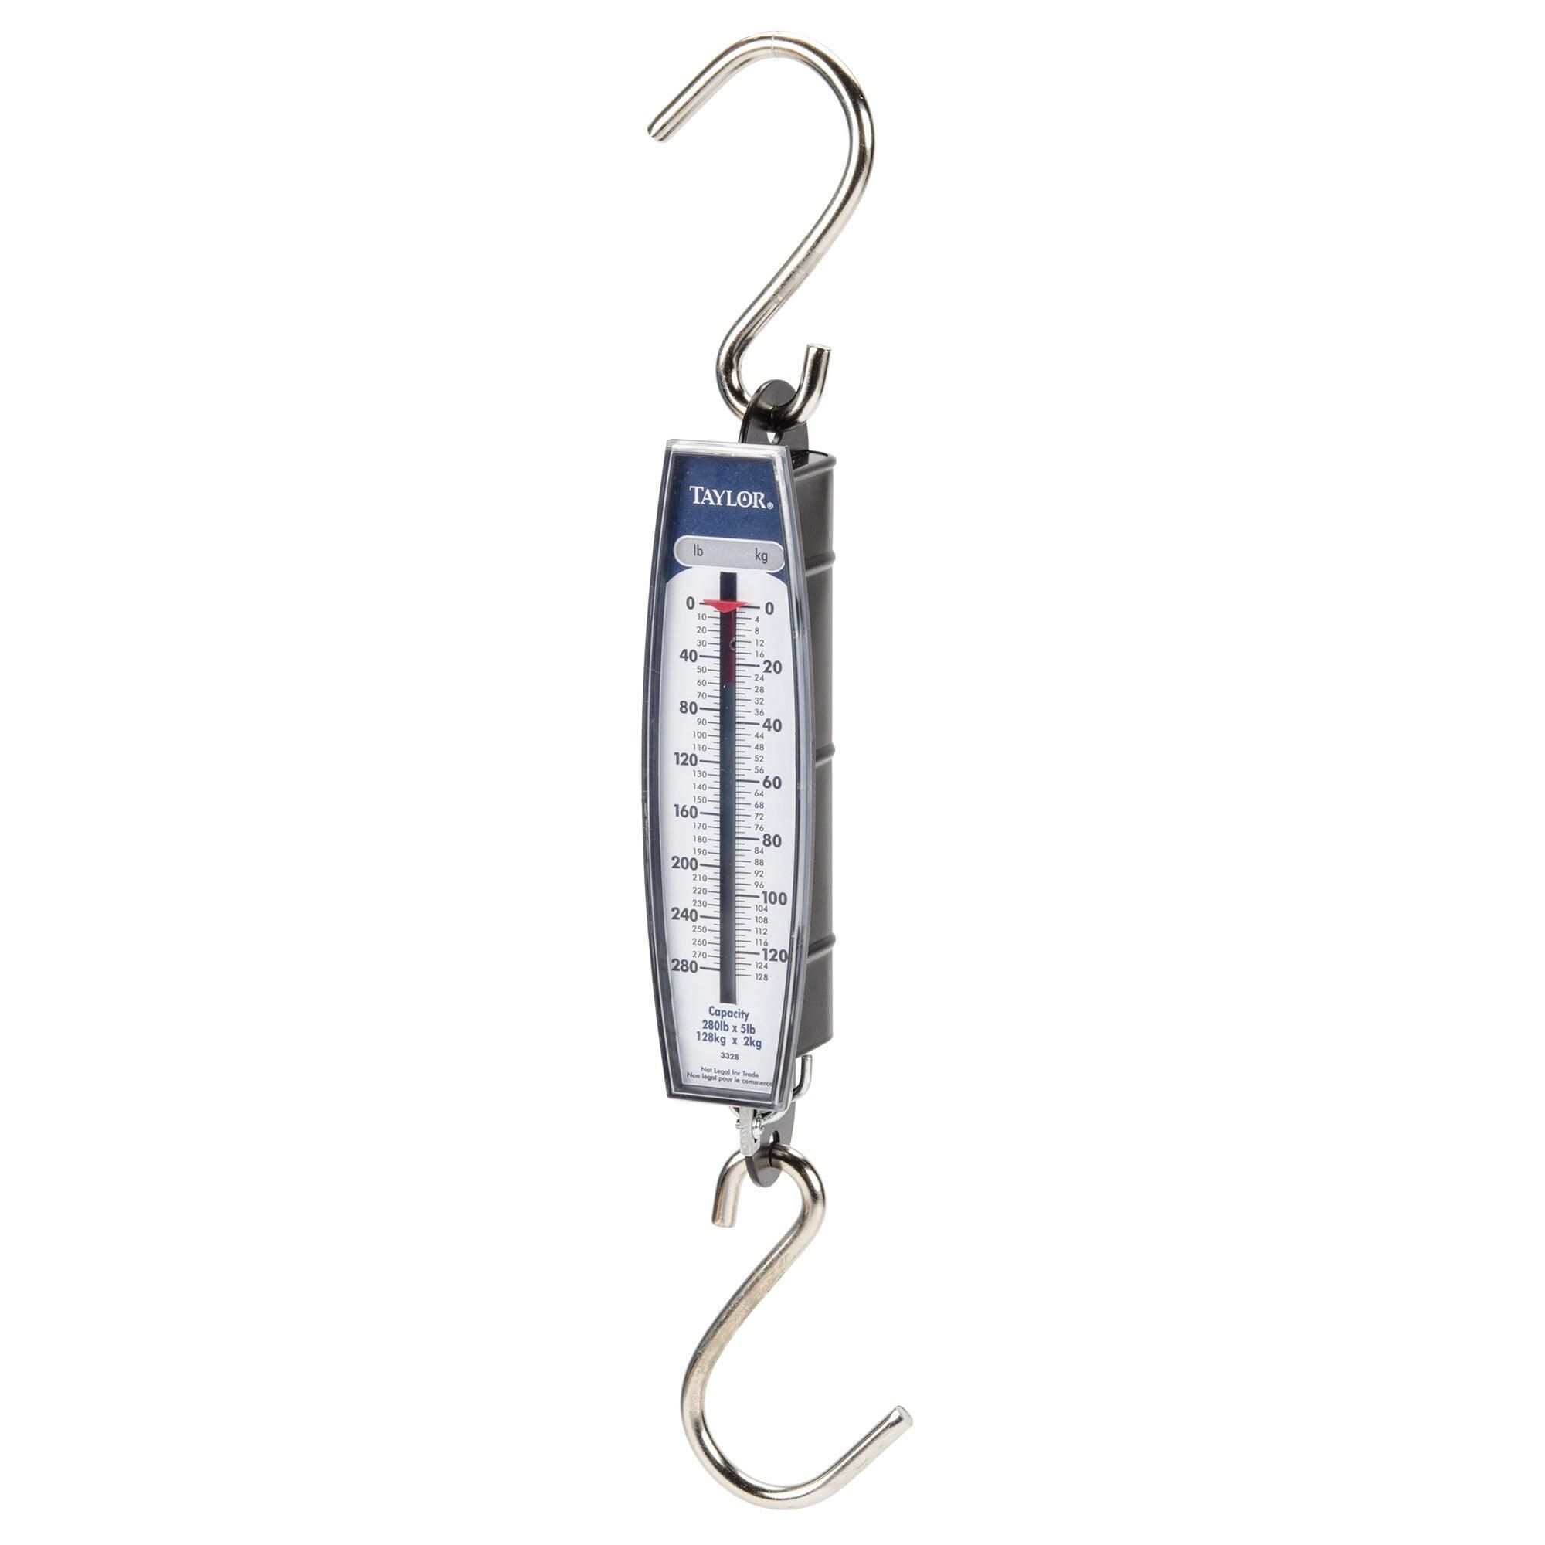
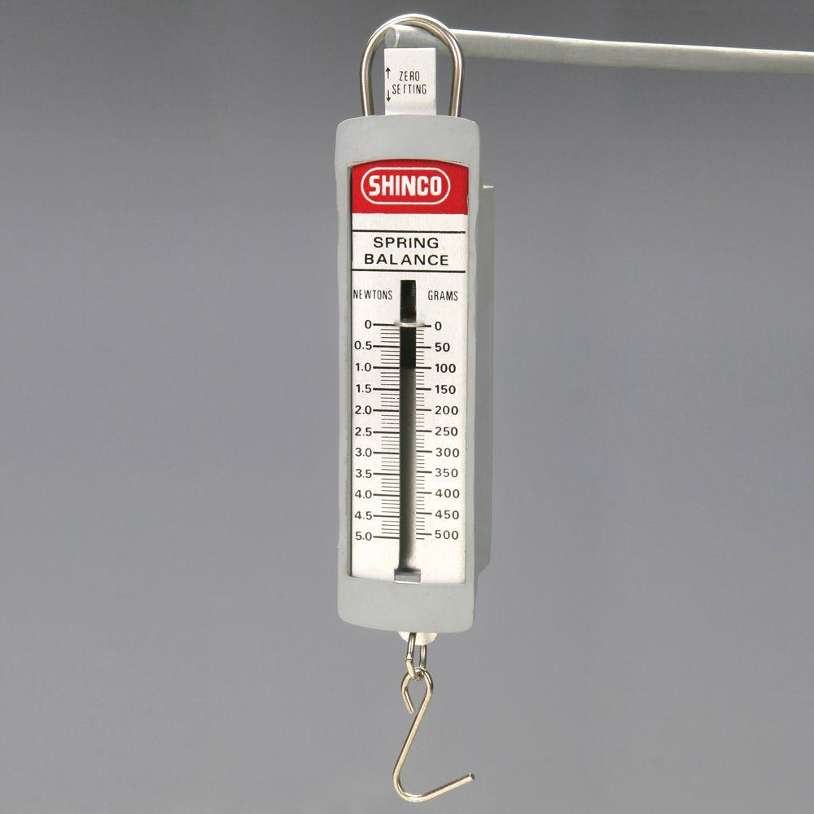
Description
The object is suspended from a hook, causing the spring to stretch.
Applications
- Physics laboratories
- Education
- General force measurements

2. Compression Spring Balance
# Source: AI Source: Provided by: [Data Path: Persons Table -> ID Column: 1, Name_En Column: Motasem Essam] -> From: [ChatGPT] on [7/17/2026]
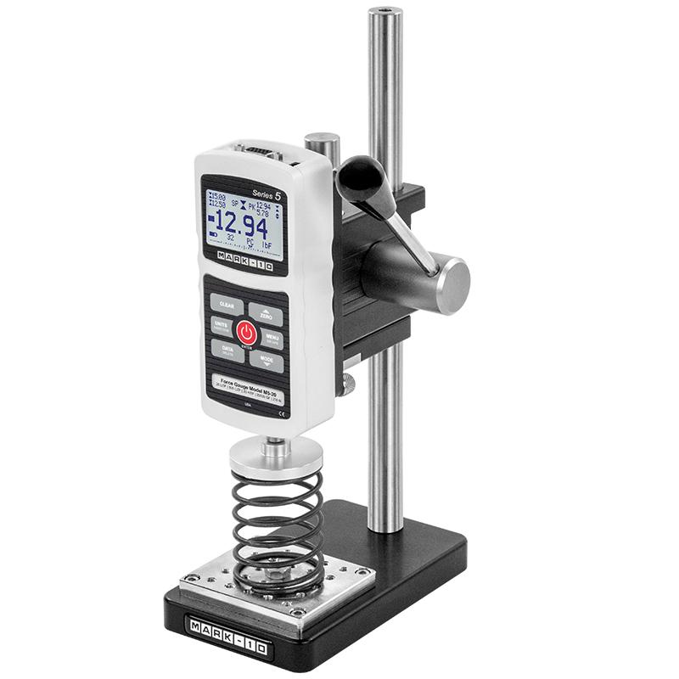
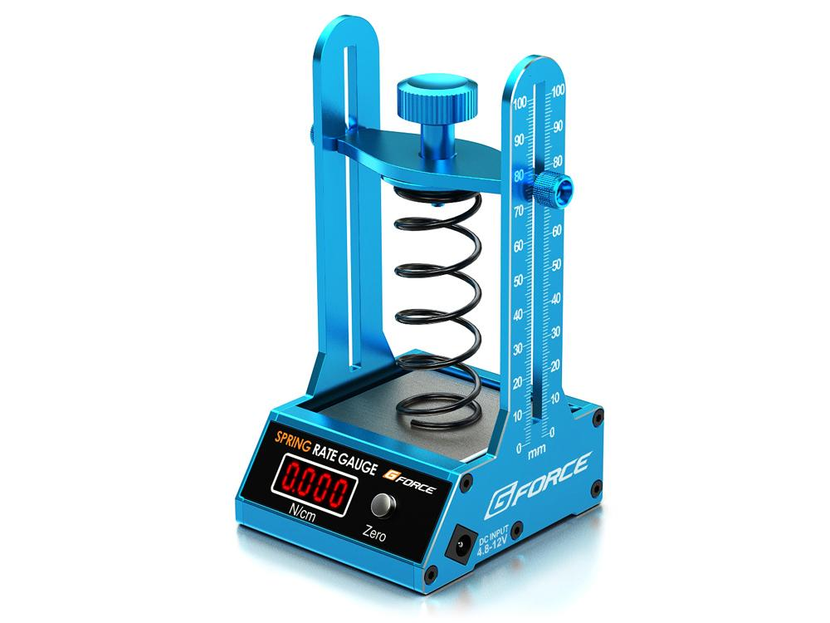
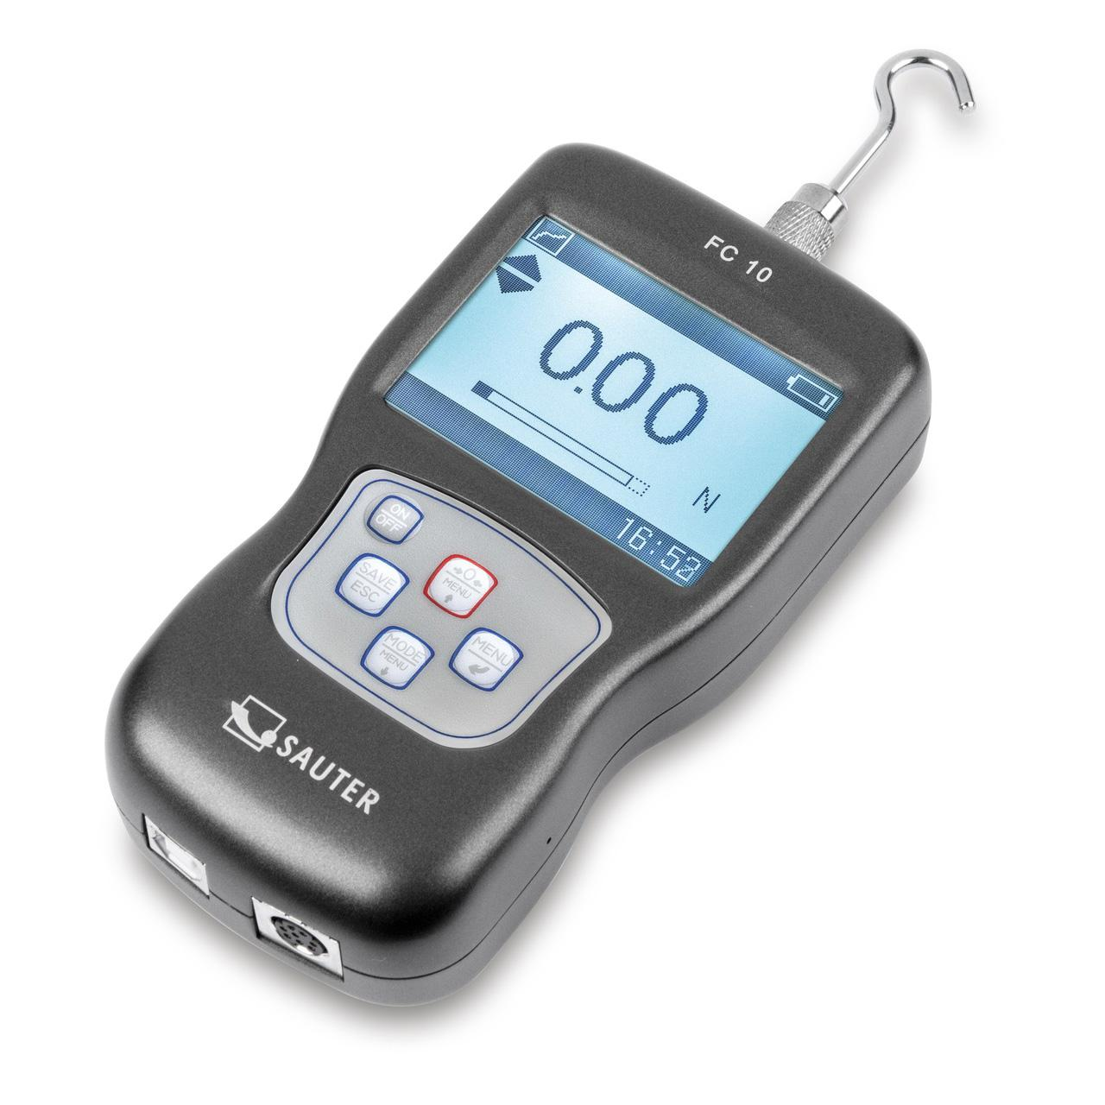
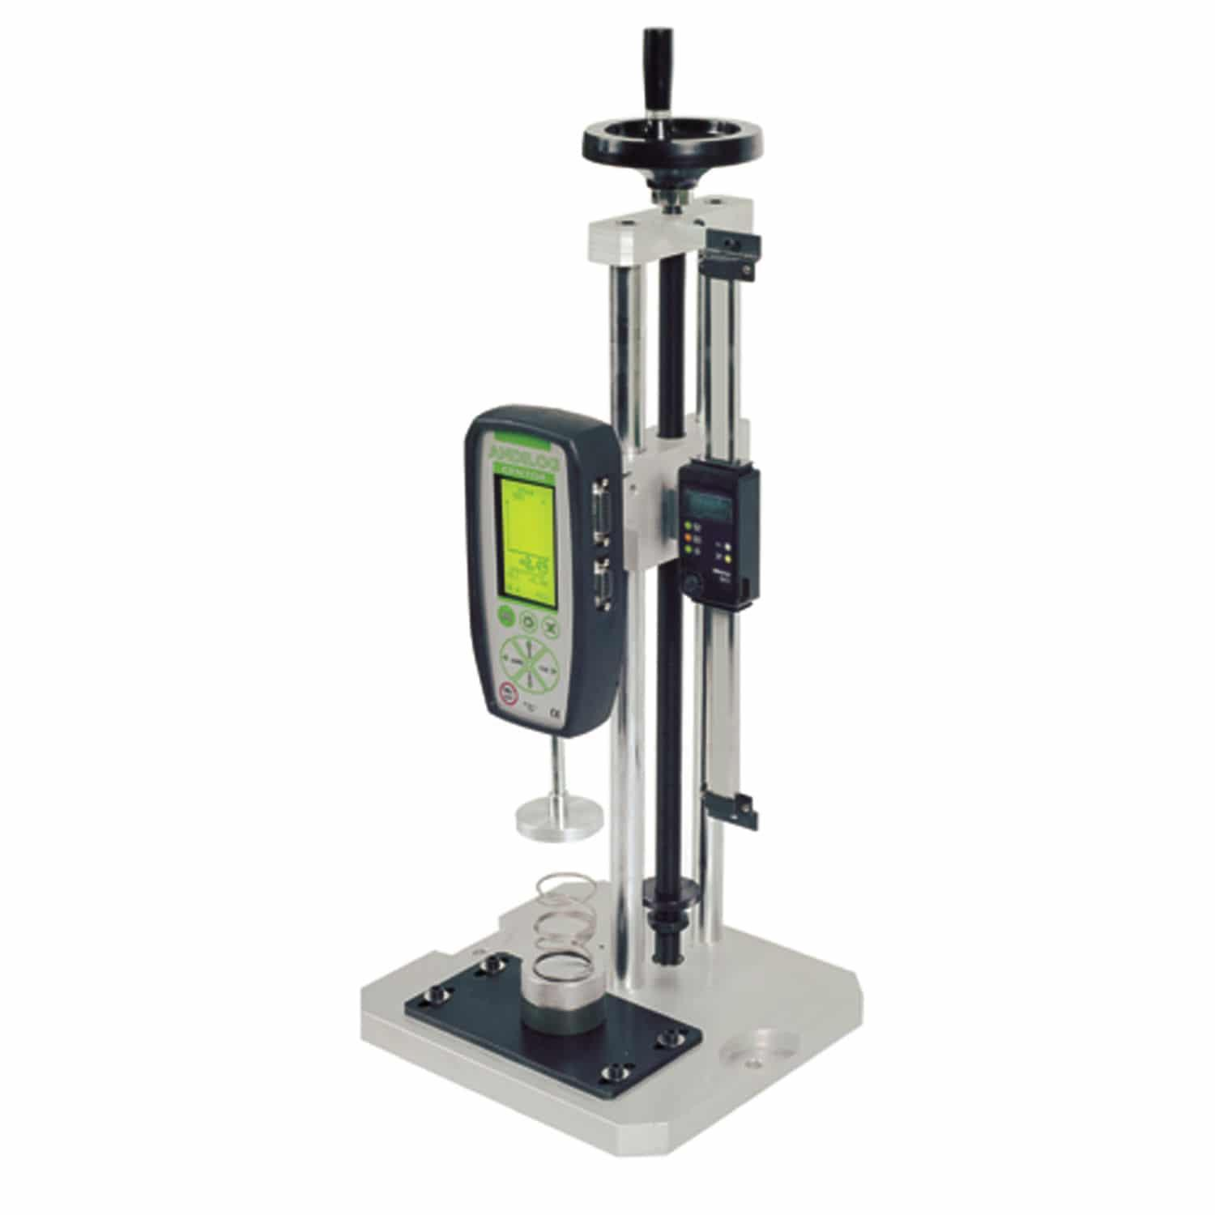
Description
Measures force by compressing the spring instead of stretching it.
Applications
- Mechanical testing
- Material testing
- Engineering

3. Portable Spring Scale
# Source: AI Source: Provided by: [Data Path: Persons Table -> ID Column: 1, Name_En Column: Motasem Essam] -> From: [ChatGPT] on [7/17/2026]
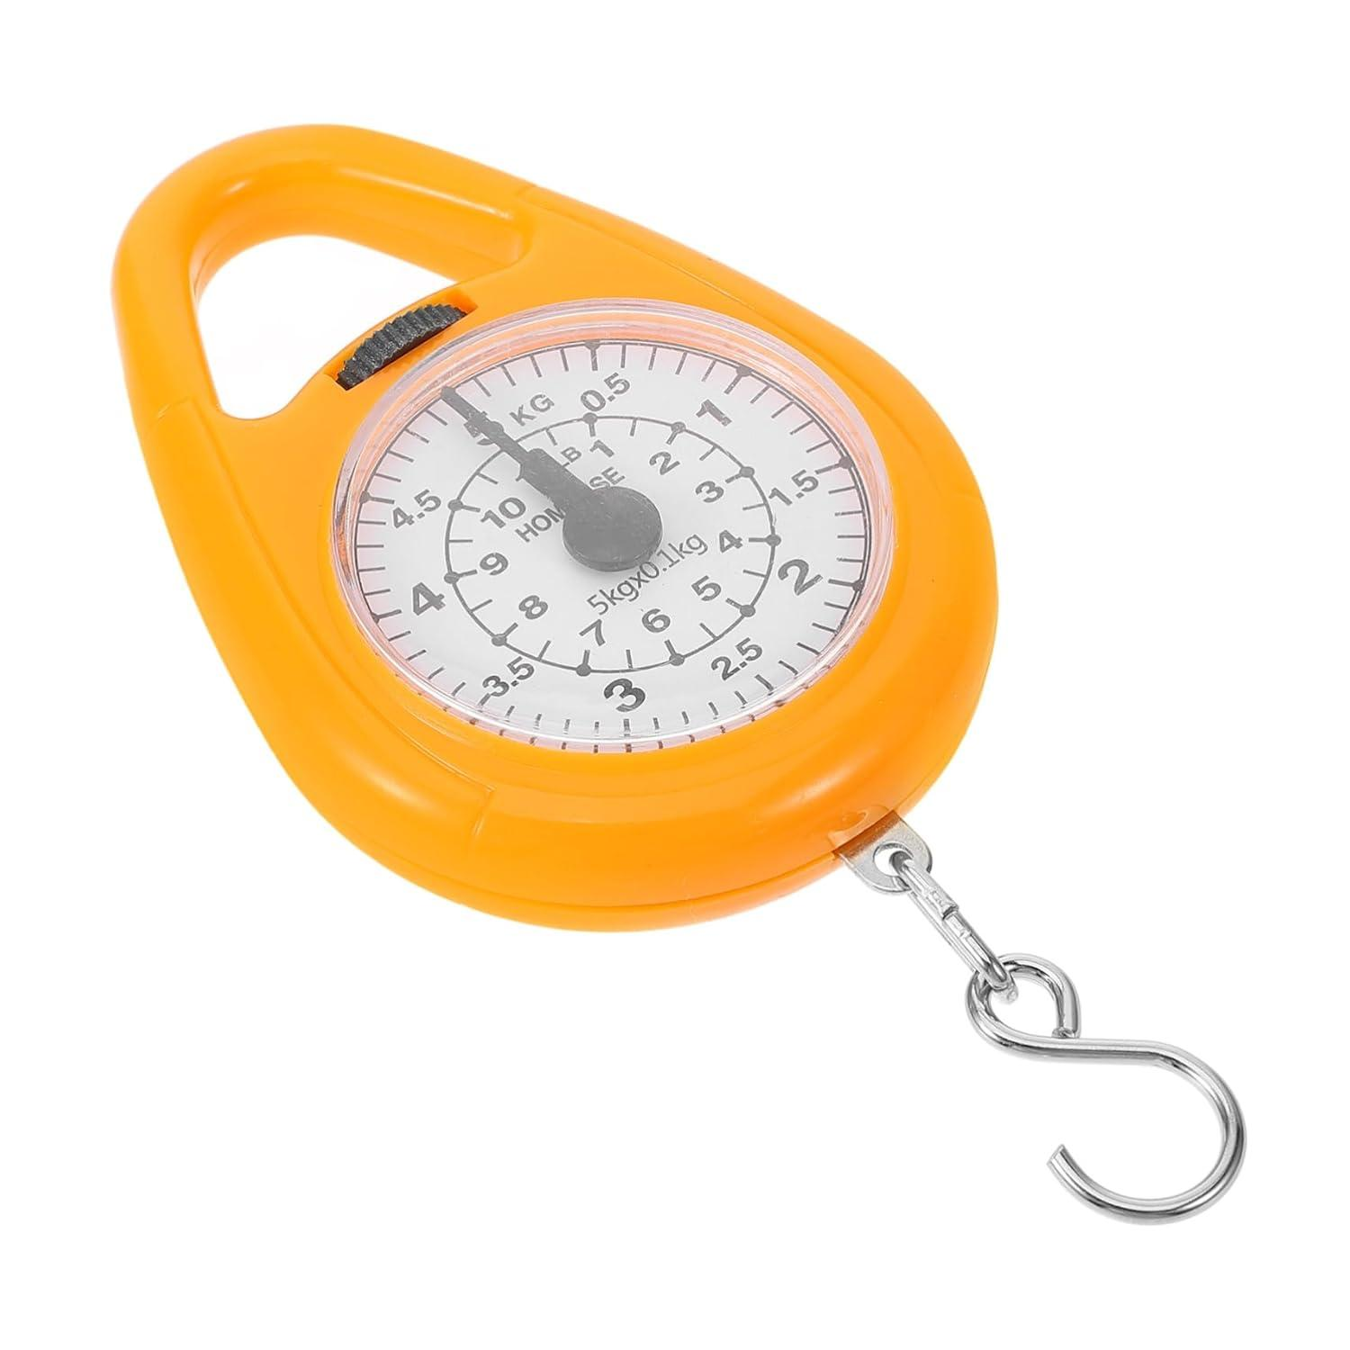
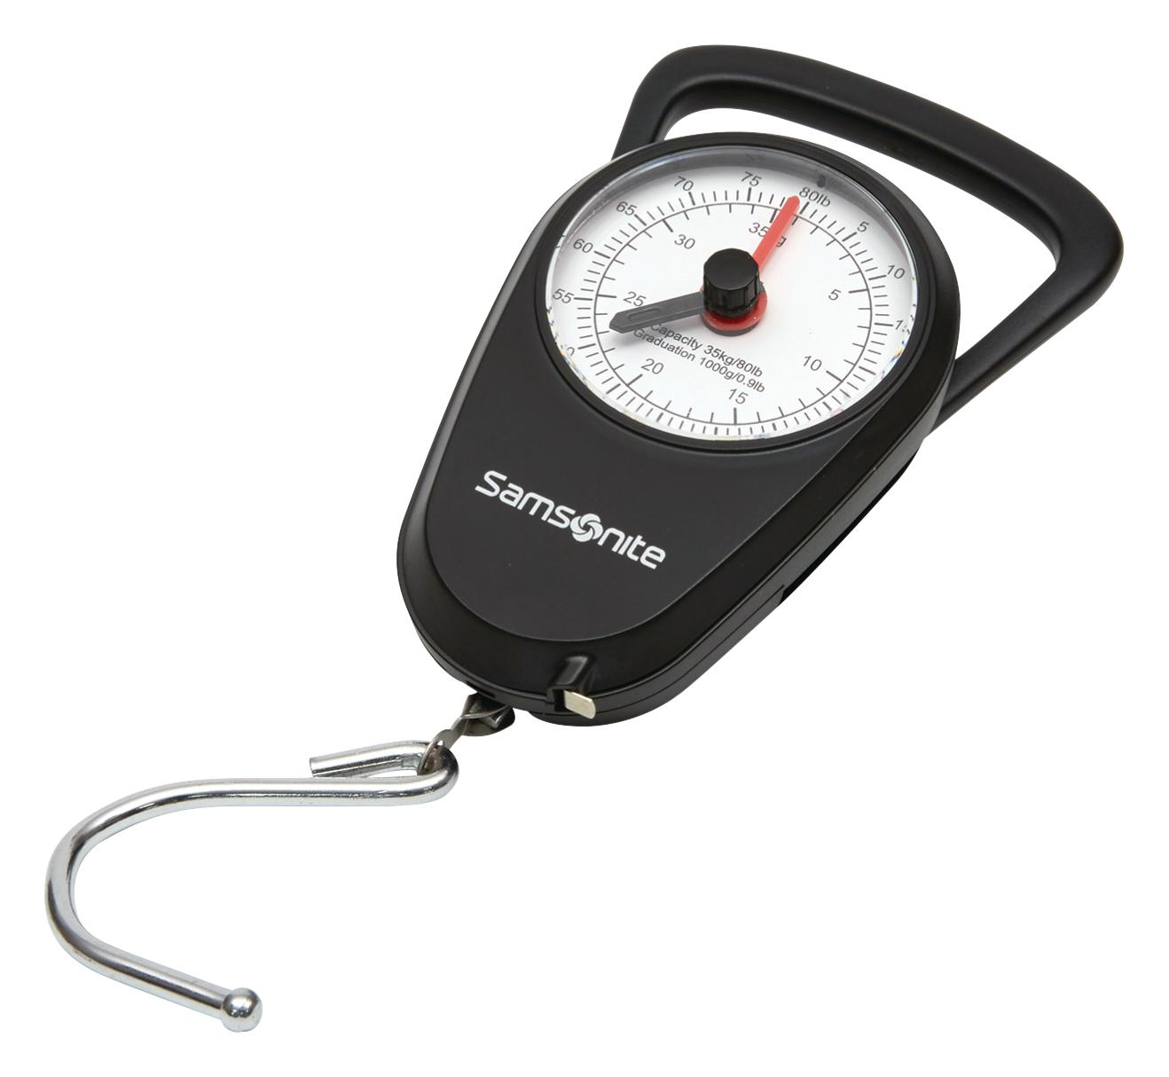
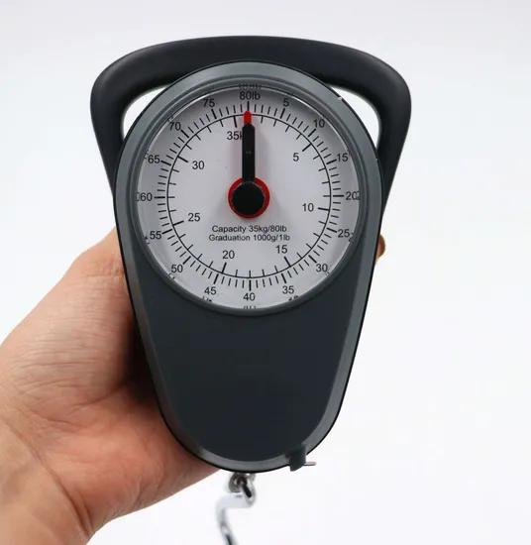
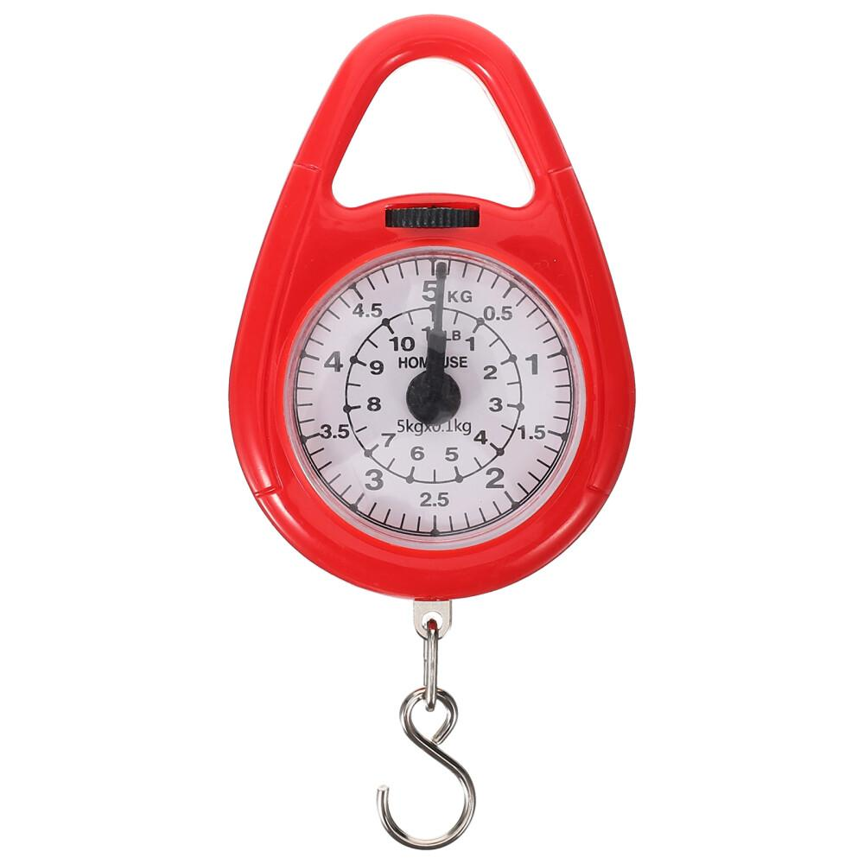
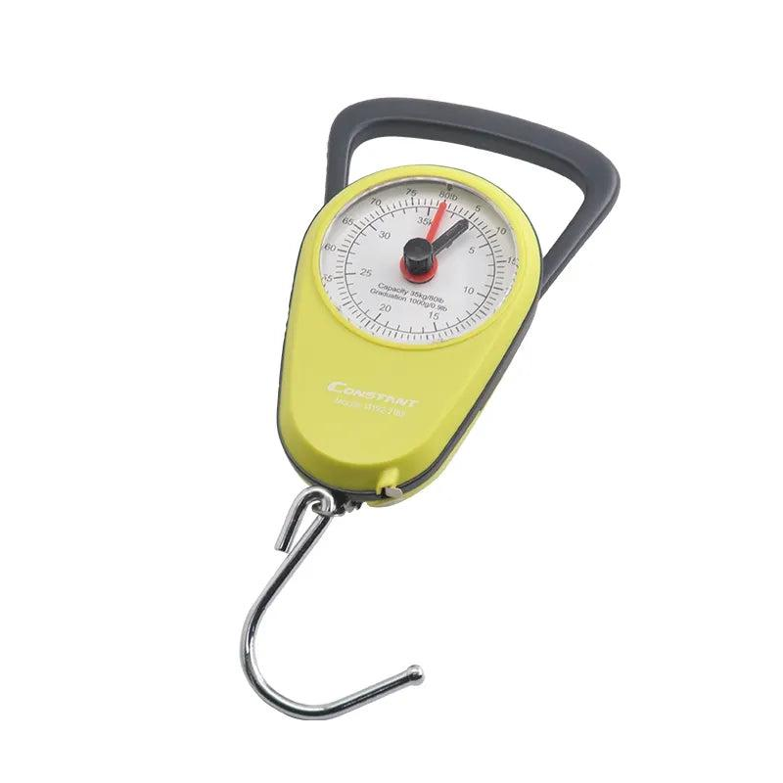
Description
A compact spring balance designed for field use.
Applications
- Fishing
- Luggage weighing
- Outdoor activities

4. Laboratory Spring Balance
# Source: AI Source: Provided by: [Data Path: Persons Table -> ID Column: 1, Name_En Column: Motasem Essam] -> From: [ChatGPT] on [7/17/2026]
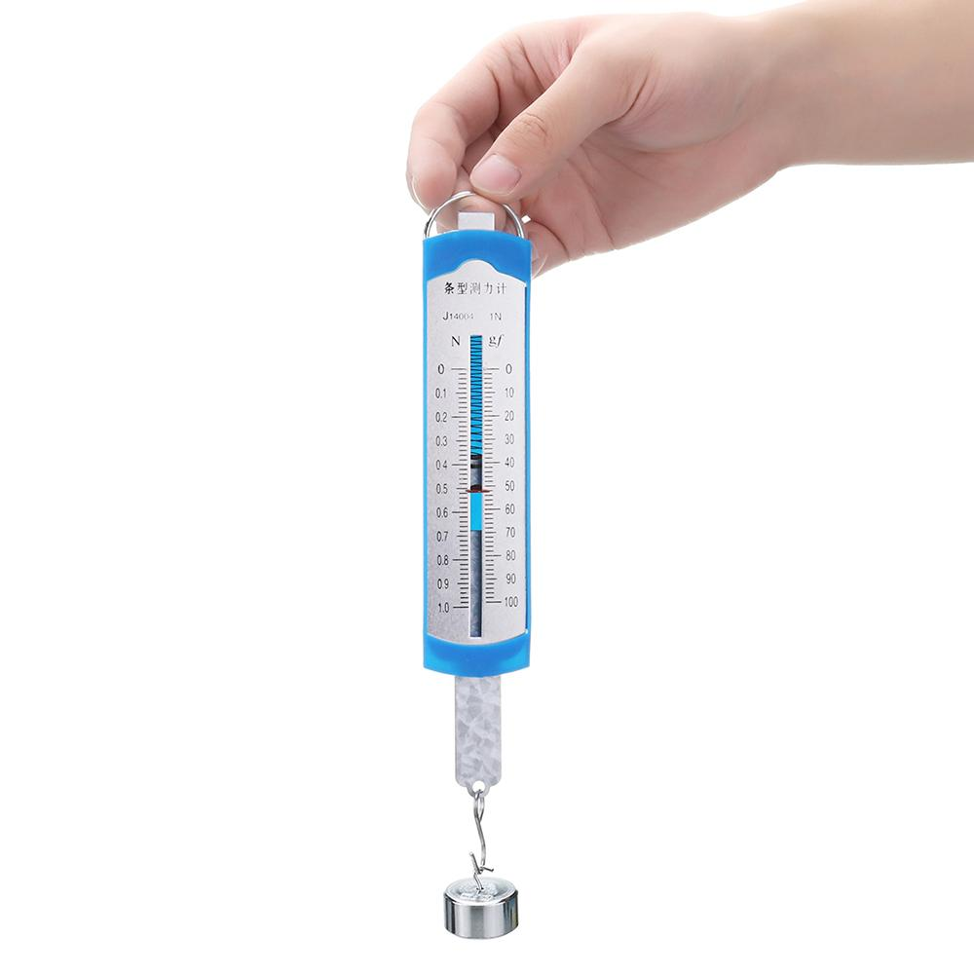
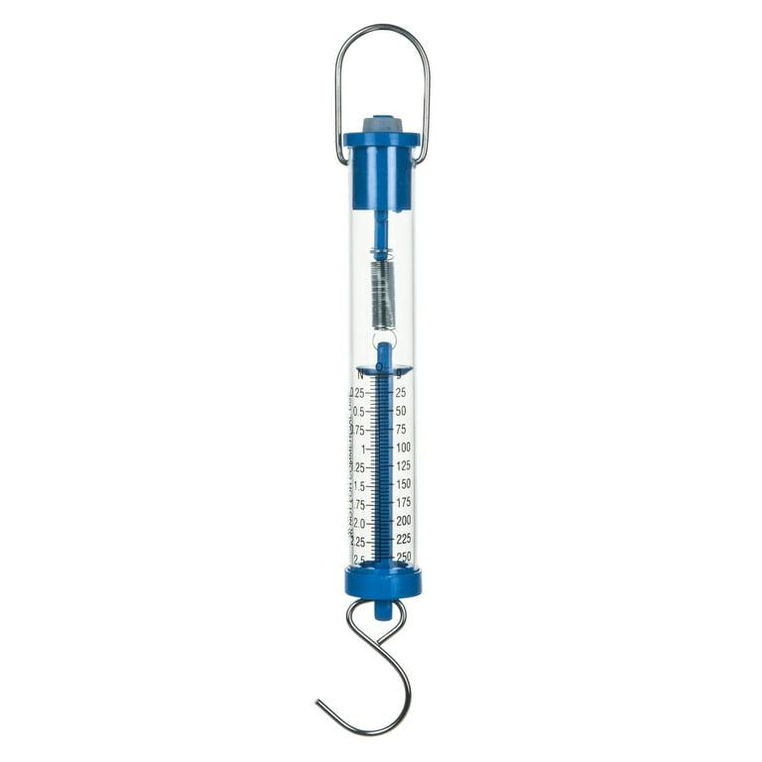
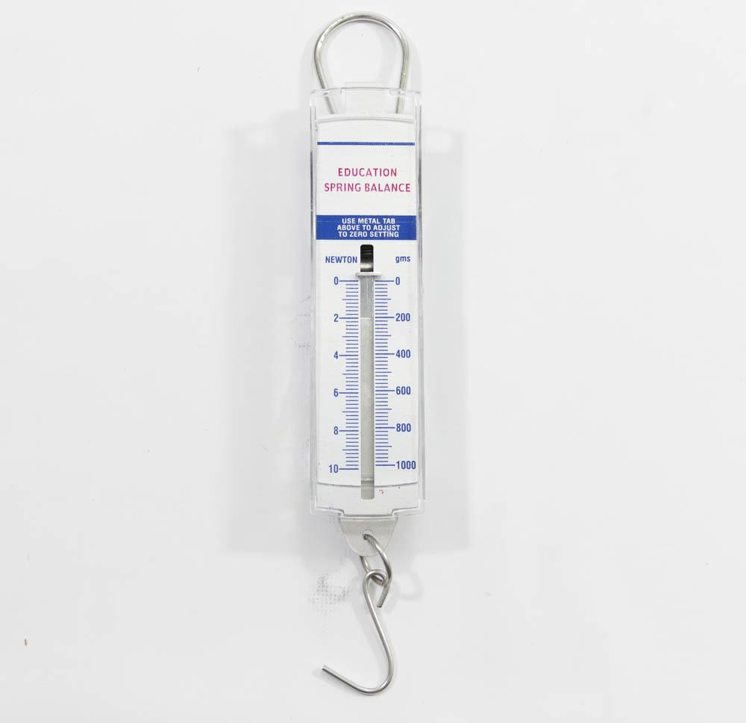
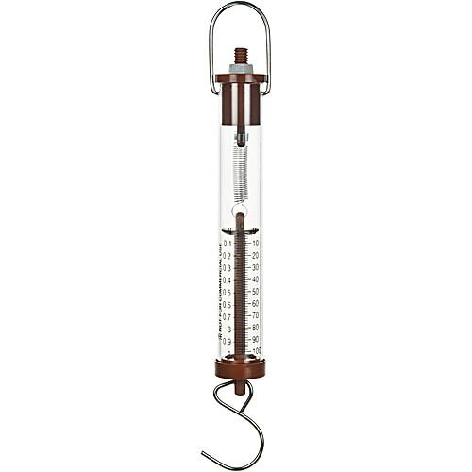
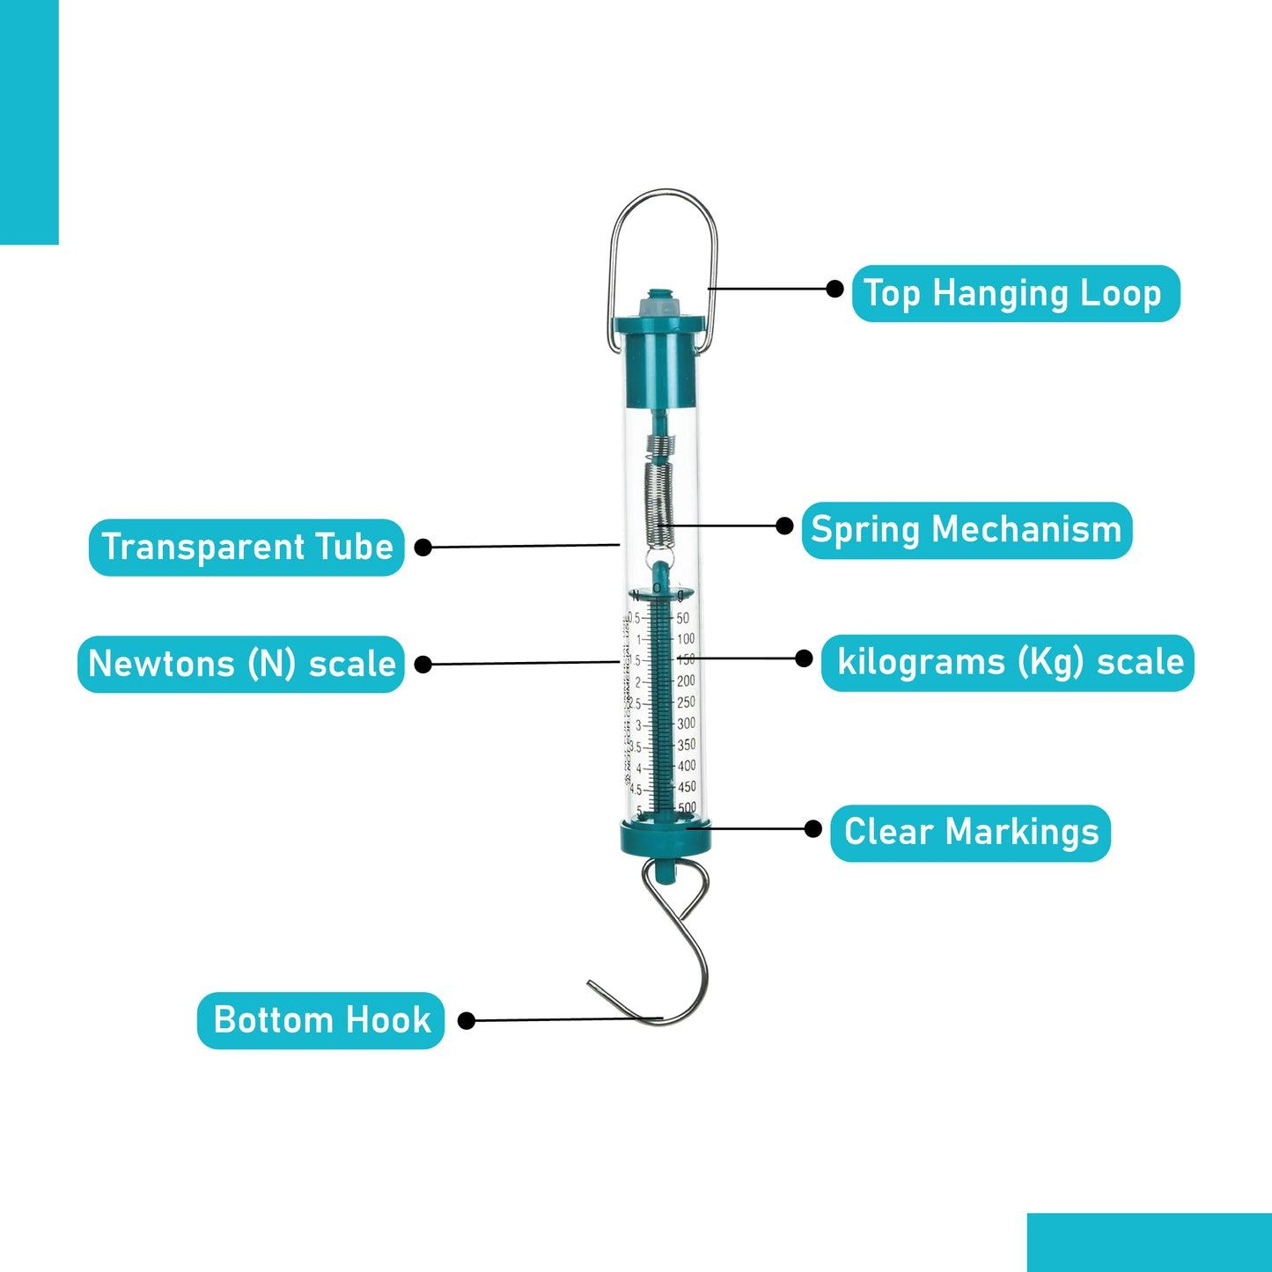
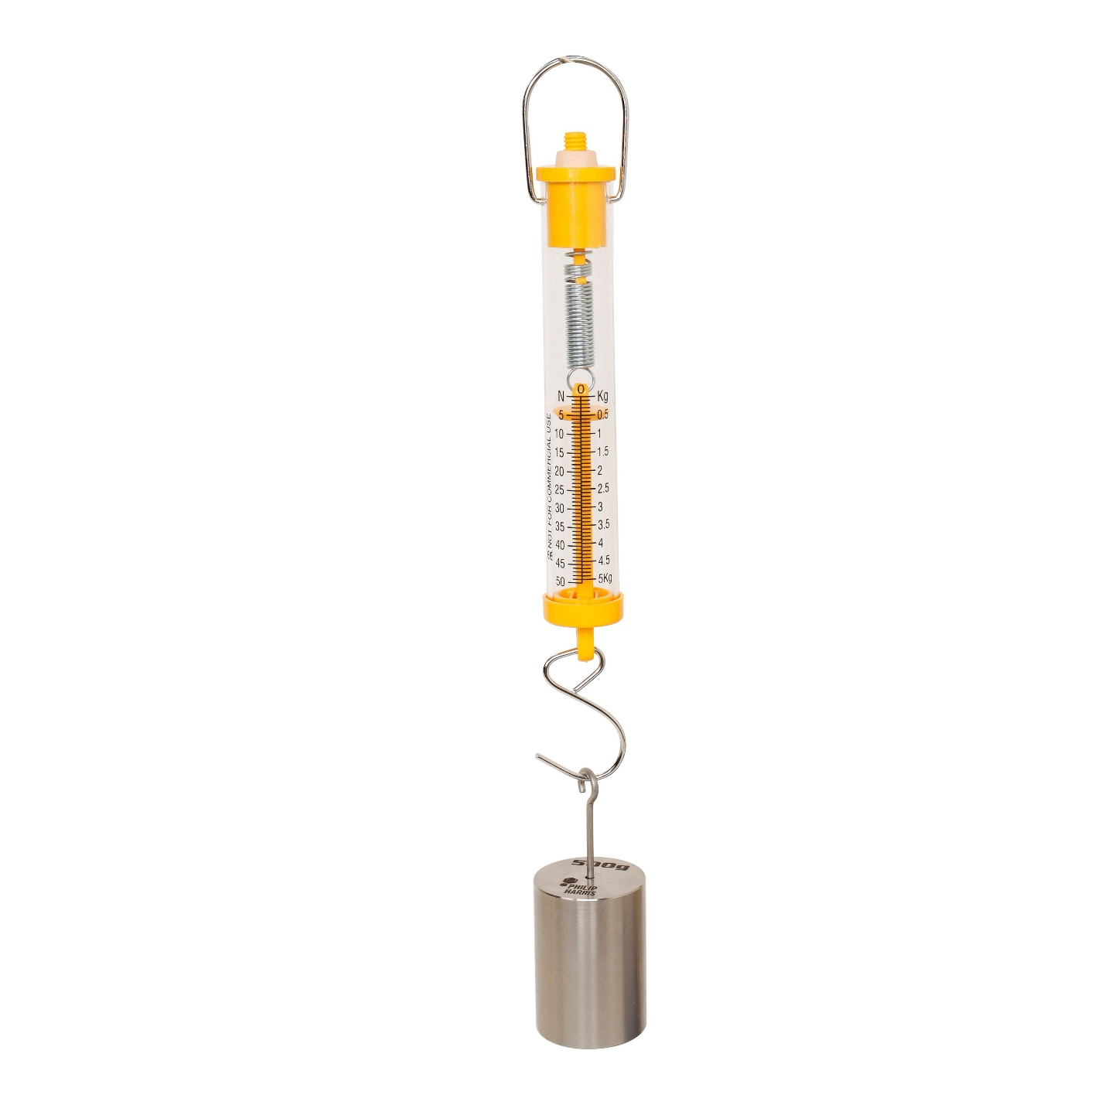
Description
A precision spring balance used for scientific experiments.
Applications
- Physics laboratories
- Educational demonstrations
- Research

Measuring Units
# Source: AI Source: Provided by: [Data Path: Persons Table -> ID Column: 1, Name_En Column: Motasem Essam] -> From: [ChatGPT] on [7/17/2026]
Spring balances commonly measure:
- Newton (N) (SI unit of force)
- Kilogram-force (kgf)
- Gram-force (gf)
- Pound-force (lbf)

Measuring Range
# Source: AI Source: Provided by: [Data Path: Persons Table -> ID Column: 1, Name_En Column: Motasem Essam] -> From: [ChatGPT] on [7/17/2026]
The measuring range depends on the balance size and intended application.
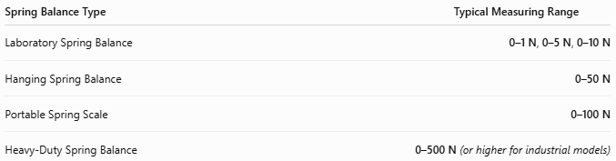
Spring Balance Type | Typical Measuring Range
Laboratory Spring Balance | 0–1 N, 0–5 N, 0–10 N
Hanging Spring Balance | 0–50 N
Portable Spring Scale | 0–100 N
Heavy-Duty Spring Balance | 0–500 N (or higher for industrial models)

Resolution
# Source: AI Source: Provided by: [Data Path: Persons Table -> ID Column: 1, Name_En Column: Motasem Essam] -> From: [ChatGPT] on [7/17/2026]
Resolution is the smallest force increment that can be read from the scale.
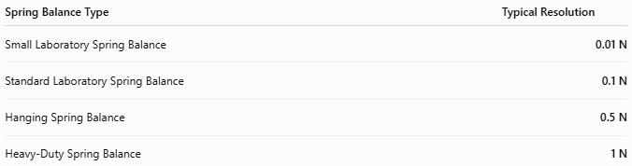
Spring Balance Type | Typical Resolution
Small Laboratory Spring Balance | 0.01 N
Standard Laboratory Spring Balance | 0.1 N
Hanging Spring Balance | 0.5 N
Heavy-Duty Spring Balance | 1 N

Accuracy
# Source: AI Source: Provided by: [Data Path: Persons Table -> ID Column: 1, Name_En Column: Motasem Essam] -> From: [ChatGPT] on [7/17/2026]
Accuracy indicates how closely the measured force matches the true applied force.
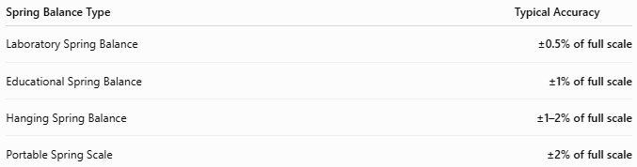
Spring Balance Type | Typical Accuracy
Laboratory Spring Balance | ±0.5% of full scale
Educational Spring Balance | ±1% of full scale
Hanging Spring Balance | ±1–2% of full scale
Portable Spring Scale | ±2% of full scale
Notes
- Accuracy is highest when measurements remain within the spring's elastic limit.
- Overloading the spring can permanently deform it and reduce accuracy.
- Readings should be taken with the scale viewed perpendicular to avoid parallax error.
- Periodic calibration improves long-term reliability.

How to Use a Spring Balance
# Source: AI Source: Provided by: [Data Path: Persons Table -> ID Column: 1, Name_En Column: Motasem Essam] -> From: [ChatGPT] on [7/17/2026]
- Suspend or hold the spring balance vertically.
- Ensure the pointer reads zero before use.
- Attach the object to the hook.
- Wait until the spring stops oscillating.
- Read the force from the graduated scale.

Example
# Source: AI Source: Provided by: [Data Path: Persons Table -> ID Column: 1, Name_En Column: Motasem Essam] -> From: [ChatGPT] on [7/17/2026]
Reading on the scale:
12.5 N
Measured force:
12.5 Newtons

Applications
# Source: AI Source: Provided by: [Data Path: Persons Table -> ID Column: 1, Name_En Column: Motasem Essam] -> From: [ChatGPT] on [7/17/2026]
Spring balances are used in:
- Physics laboratories
- Schools
- Engineering
- Material testing
- Fishing
- Agriculture
- Field measurements
- Mechanical maintenance

Advantages
# Source: AI Source: Provided by: [Data Path: Persons Table -> ID Column: 1, Name_En Column: Motasem Essam] -> From: [ChatGPT] on [7/17/2026]
A spring balance:
- Is simple to operate.
- Requires no electrical power.
- Is inexpensive.
- Is portable.
- Provides direct force measurements.
- Is useful for educational demonstrations.

Limitations
# Source: AI Source: Provided by: [Data Path: Persons Table -> ID Column: 1, Name_En Column: Motasem Essam] -> From: [ChatGPT] on [7/17/2026]
A spring balance:
- Must remain within the spring's elastic limit.
- Is less accurate than electronic force sensors.
- Can lose calibration after repeated use.
- Is affected by spring fatigue over time.

Sources of Error
# Source: AI Source: Provided by: [Data Path: Persons Table -> ID Column: 1, Name_En Column: Motasem Essam] -> From: [ChatGPT] on [7/17/2026]
Instrument Errors
- Spring fatigue
- Calibration drift
- Damaged pointer

User Errors
- Reading from an angle (parallax error)
- Overloading the spring
- Measuring while the spring is oscillating

Environmental Errors
- Temperature changes affecting spring properties
- Corrosion
- Mechanical wear

Comparison with Other Force Measuring Instruments
# Source: AI Source: Provided by: [Data Path: Persons Table -> ID Column: 1, Name_En Column: Motasem Essam] -> From: [ChatGPT] on [7/17/2026]
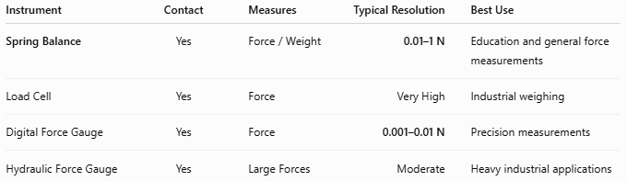
Instrument | Contact | Measures | Typical Resolution | Best Use
Spring Balance | Yes | Force / Weight | 0.01–1 N | Education and general force measurements
Load Cell | Yes | Force | Very High | Industrial weighing
Digital Force Gauge | Yes | Force | 0.001–0.01 N | Precision measurements
Hydraulic Force Gauge | Yes | Large Forces | Moderate | Heavy industrial applications

Care and Maintenance
# Source: AI Source: Provided by: [Data Path: Persons Table -> ID Column: 1, Name_En Column: Motasem Essam] -> From: [ChatGPT] on [7/17/2026]
To maintain accuracy:
- Do not overload the spring.
- Store in a dry environment.
- Avoid impacts and drops.
- Calibrate periodically.
- Keep the spring clean and free of corrosion.

Common Mistakes
# Source: AI Source: Provided by: [Data Path: Persons Table -> ID Column: 1, Name_En Column: Motasem Essam] -> From: [ChatGPT] on [7/17/2026]
- Using the spring beyond its maximum capacity.
- Reading the scale before the pointer stabilizes.
- Holding the balance at an angle.
- Assuming it measures mass directly instead of force.

Key Points
# Source: AI Source: Provided by: [Data Path: Persons Table -> ID Column: 1, Name_En Column: Motasem Essam] -> From: [ChatGPT] on [7/17/2026]
- A Spring Balance measures force, not mass.
- It operates according to Hooke's Law.
- Common types:
  - Hanging Spring Balance
  - Compression Spring Balance
  - Portable Spring Scale
  - Laboratory Spring Balance
- Common units:
  - Newton (N)
  - kgf
  - gf
  - lbf
- It is widely used in education, laboratories, engineering, and field measurements.

Conclusion
# Source: AI Source: Provided by: [Data Path: Persons Table -> ID Column: 1, Name_En Column: Motasem Essam] -> From: [ChatGPT] on [7/17/2026]
A Spring Balance is a simple, reliable, and widely used force-measuring instrument that determines the magnitude of force by measuring the extension or compression of a calibrated spring. Its operation based on Hooke's Law makes it an excellent educational tool and a practical instrument for everyday force and weight measurements in laboratories, engineering, industry, and field applications.

